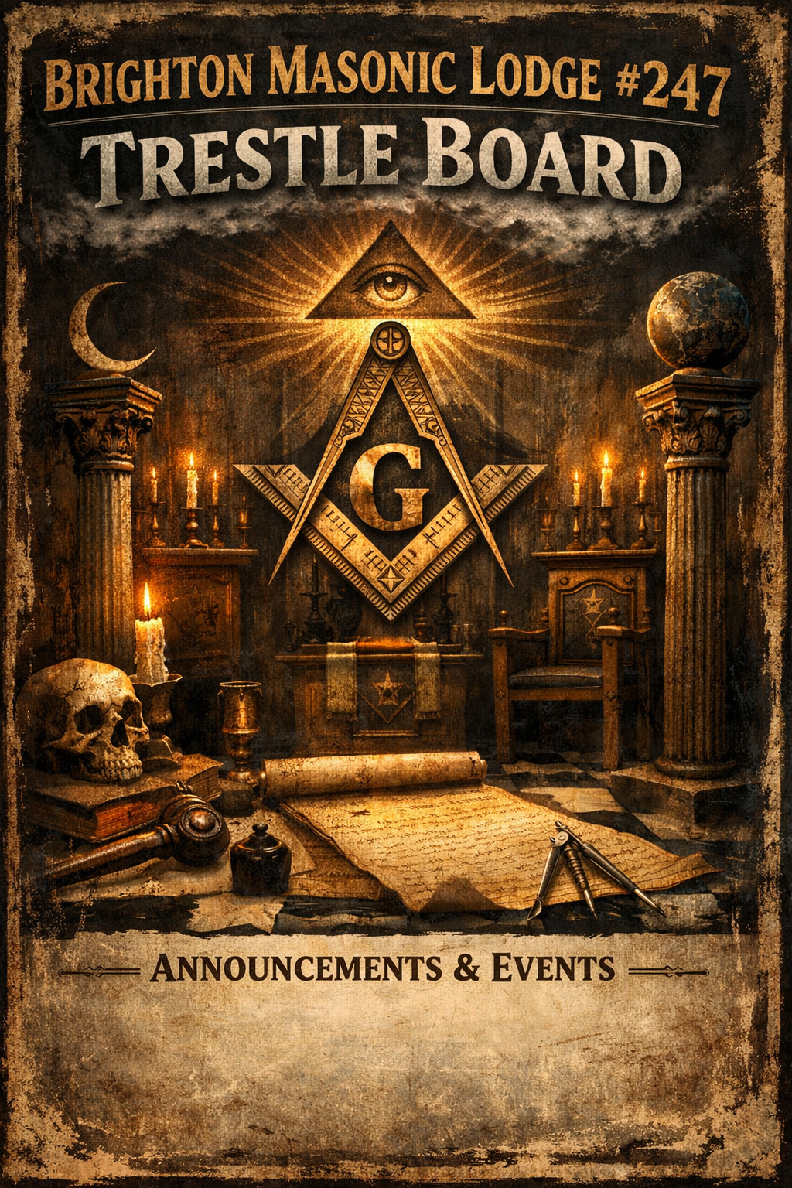
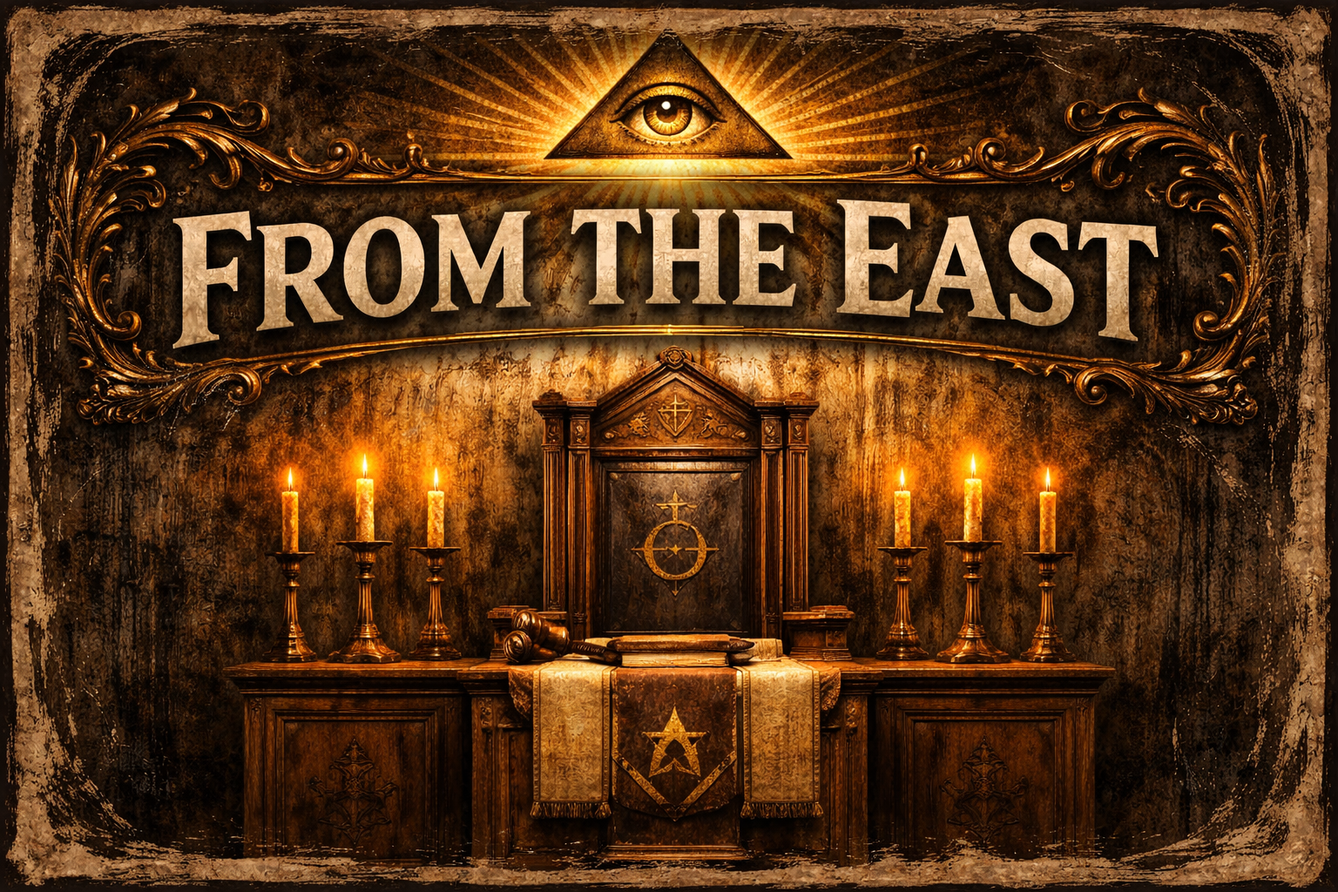
Brothers,
As August arrives, we find ourselves at a natural turning point in the year. Summer is beginning to wind down, families are preparing for the start of a new school year, and many of us are returning to more familiar routines. It is also an ideal time to refocus on the work of our lodge and the principles that unite us as Freemasons.
Brighton Lodge No. 247 continues to grow because of the dedication, generosity, and fellowship of its members. Whether you have attended every meeting this year or have been away for a while, each brother is an important part of our lodge. The friendships we build, the traditions we uphold, and the service we provide to our community are strengthened when we come together.
The months ahead offer many opportunities to reconnect, serve, and enjoy the fellowship that makes our fraternity so meaningful. From charitable projects and community events to degree work and social gatherings, there is a place for every brother to contribute. If you have been looking for an opportunity to become more involved, there has never been a better time to do so.
As our schedules become busier with the arrival of fall, I encourage each of you to set aside time for your lodge. Even attending a single meeting or volunteering for one event can make a meaningful difference. Your participation helps ensure that Brighton Lodge remains a vibrant and welcoming place for both longtime members and those just beginning their Masonic journey.
As we move through the remainder of the year, let us continue to support one another, strengthen our bonds of brotherhood, and remain committed to serving our community with integrity, compassion, and purpose. Together, we can finish the year with the same enthusiasm and dedication that have defined our lodge throughout 2026.
Our focus for the months ahead continues to center on several important goals:
• Raising the Profile of Masonry in Our Community – Ensuring that our Lodge is visible, active, and known for the positive impact we make.
• Creating Opportunities for Brothers to Engage – Both inside and outside the Lodge through fellowship activities as well as hands-on charity opportunities where we can work together and serve others.
• Educating and Supporting Our New Brothers – Through mentoring, involvement, and guidance so that each new Mason feels welcomed, supported, and able to grow without becoming overwhelmed.
• Encouraging Family and Friends Involvement – Through events such as game nights, picnics, social gatherings, and service projects that allow those closest to us to share in the fellowship of the Lodge.
• Practice and Ritual – Continuing to strengthen our ritual work through practice and participation so that we maintain the high standards expected of our Craft.
Fraternally,
Garrett Graham, WM
Brighton Lodge No. 247

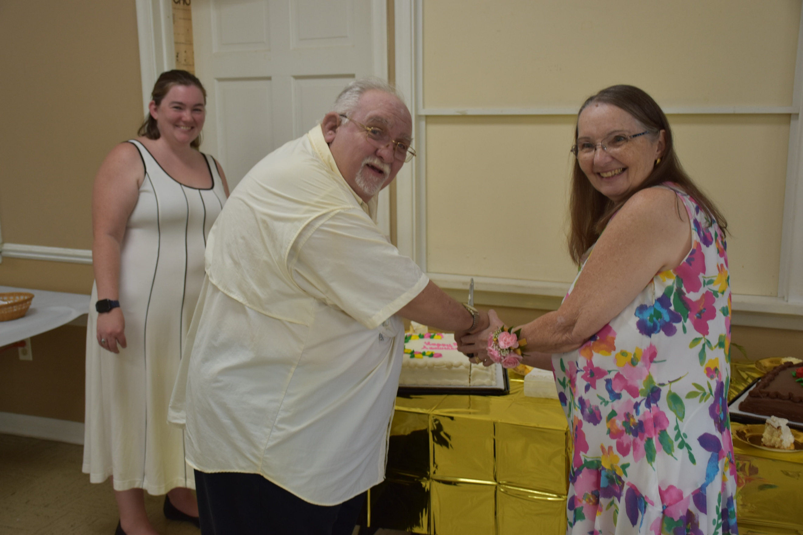

40Yr’s a Brother &

50Yr’s A Good Man
We would like to take a moment to honor a truly remarkable man, Worshipful Brother Louis D. Scott—known to so many of us simply as Louie, or affectionately as "Yoda."
For 40 years, Worshipful Brother Scott has exemplified what it means to be a Mason. His wisdom, humility, quiet strength, and unwavering dedication have left a lasting mark on our Lodge and on every Brother fortunate enough to know him. He has never sought recognition, yet his actions have earned the deepest respect. He has been a mentor, a friend, and an example of the values we all strive to live by.
Like the nickname "Yoda" suggests, Louie has shared wisdom not just through words, but through the way he has lived his life—with patience, compassion, integrity, and a genuine willingness to help others grow. His steady presence has reminded us that true leadership comes through service and that the strongest foundations are built with kindness and character.
As if celebrating four decades of outstanding service to the Craft were not enough, Louie has also reached another extraordinary milestone: 50 years of marriage. Half a century of love, commitment, faithfulness, and partnership is a rare and beautiful achievement. It speaks volumes about the man he is not only as a Mason, but as a husband, a family man, and a person of unwavering devotion.
Worshipful Brother Louis D. Scott, your legacy is measured not just in years, but in lives touched, lessons shared, and friendships forged. Thank you for your faithful service, your steady guidance, and the example you have set for generations of Brothers. May the years ahead continue to bring you good health, happiness, and the satisfaction of knowing how deeply you are appreciated and respected.
Congratulations on your upcoming 40 years of outstanding Masonic service and on celebrating 50 wonderful years of marriage. Your life is a testament to the enduring power of love, loyalty, faith, and brotherhood. It is an honor to call you our Brother.
Fraternally,
Garrett Graham, WM
Brighton Lodge No. 247

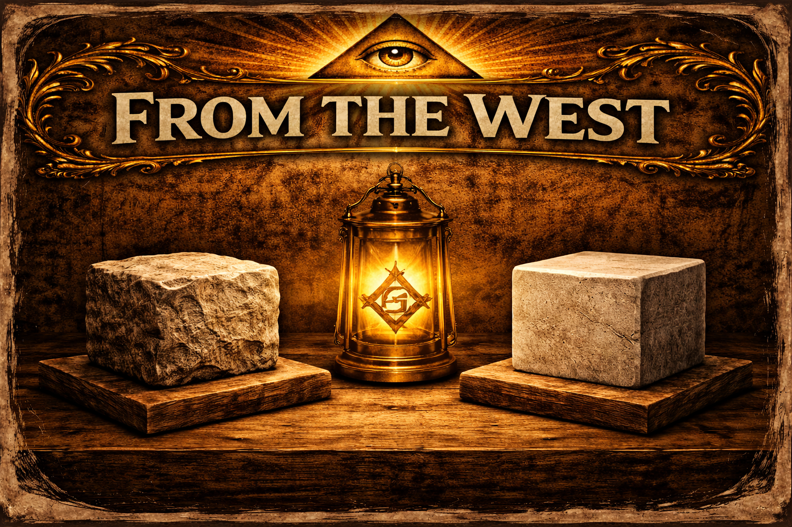
Upcoming Charity Golf Outing’s

Upcoming Masonic Golf Outings – Join the Fun & Support a Great Cause!
Brethren,
Looking for a great way to get involved, enjoy a day on the golf course, and support worthy causes? We have two excellent Masonic golf outings coming up that offer the perfect opportunity to participate in lodge events, spend time with fellow Brothers, and give back to our communities.
Reaching Higher Golf Outing
Date: September 21
Brighton Lodge has 2 spots available at no cost to Brothers who would like to attend. These spots are available on a first come, first served basis.

To reserve your spot, please contact:
Jonathon McKinney
📞 (419) 565-1950
📧 mckinney2788@gmail.com

Howell Masonic Lodge Annual Charity Golf Outing
Date: August 29
Join Howell Masonic Lodge for their annual charity golf outing. Proceeds will benefit Howell High School Scholarships and the Howell Masonic Lodge Charity Fund.

To register, scan the event QR code or contact:
Worshipful Master Mark Rothwell
📞 (810) 533-8042
Whether you're an experienced golfer or just looking to enjoy a great day with your Brothers, we encourage everyone to consider participating. These outings are a wonderful way to strengthen our fraternal bonds while making a positive impact in our communities.
We hope to see you on the course!

Fraternally,
Jonathon McKinney,
Senior Warden, Brighton Lodge #247

UPCOMING CALENDAR EVENTS
(Please refer to Grandview for more details & Updates)
https://mi.grandview.systems/users/sign_in

Aug 6TH Thursday
Regular Communication
(Dinner 6:30; Gavel 7:30)

Aug 15TH Sat
Festive Board
Open to all Brothers (Brothers ONLY!!)
(Event starts at 5pm social hour, 6pm Dinner, 7pm event start)
Location: (Brighton Lodge) (Hosted by Brighton & Howell Lodges – Open to other brothers also)
RSVP to Will Budnick & Brandon Benson

Aug 15TH Sat
Child ID Event
Location: 242 Community Church
7526 Grand River Ave, Brighton, MI 48114
Start time: 930am set up -1pm event ends

EVENTS Looking Forward
(Please refer to Grandview for more details & Updates)
https://mi.grandview.systems/users/sign_in

Sept 19TH Sat
District #31 Picnic and Disc Golf event
Open to family & friends
Location: Independence Park Whitmore Lake Mi.
Please RSVP to Oscar A. at (810) 772-1440 or by email at
Spaniard201066@gmail.com

Sept 26TH Sat
Masonic Youth Night Hosted by Brighton Lodge (escape room event)
Open to all masonic you group members (Rainbow Girls & Demolay)
Location: TBD (Escape rooms)
Please RSVP to Jon McKinney at (419) 565-1950 or by email at
Mckinney2788@gmail.com

TBDRD Sat
Highway Cleanup US23
Open to all masonic brothers and the significant others
Location: Lee Road Park and Ride
Please RSVP to John Penley at (734) 475-0783 or by email at
John@rapidrecoveryservice.com

EVENTS Looking Forward
(Please refer to Grandview for more details & Updates)
https://mi.grandview.systems/users/sign_in

Oct 3RD Sat
Past Masters and Widows Dinner (reservations limited to the first 60)
Open to all masonic brothers and the significant others
Location: Brighton Masonic Lodge
Please RSVP to Jared Schemanski at (810) 599-8779 or by email at
Schemanskij@gmail.com

 | OFFICERS 2026
Worshipful Master | Garrett Graham | (734) 578-7790
Senior Warden | Jonathon McKinney | (419) 565-1950
Junior Warden | Will Budnick | (203) 751-3139
Treasurer | Daniel S. Powell | (810) 383-2370
Secretary | Jim Watters PM | (810) 360-3608
Senior Deacon | Mike Wilkinson | (248) 514-9322
Junior Deacon | Scott Fust | (248) 974-0936
Senior Steward | Chris Byrd | (313) 290-1900
Junior Steward | Robert Martin | (734) 341-2229
Chaplain | John Penley PM | (734) 474-0783
Marshall | Mason Stanbury | (954) 952-6518
Tiler | Patrick J. Tucker PM | (810) 599-4041
Lodge Education Officer | George Brutchen PM | (765) 730-1630
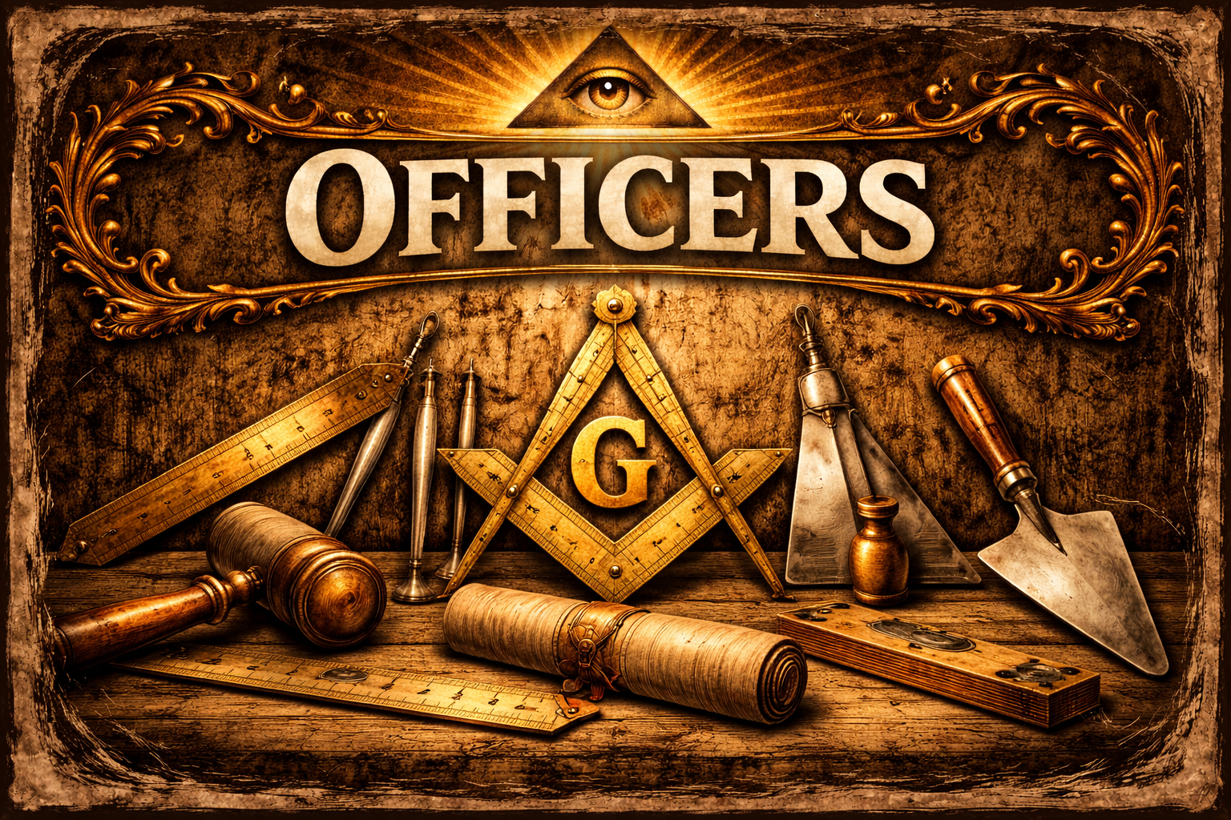
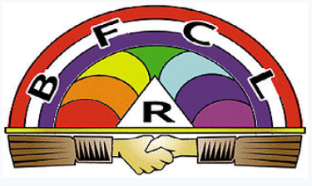

Please come out and support our local Girls masonic youth group. This is a great opportunity to support some of our young adults through our Masonic youth organization.
Coney Night 5-7pm Upcoming Dates:
TBD

